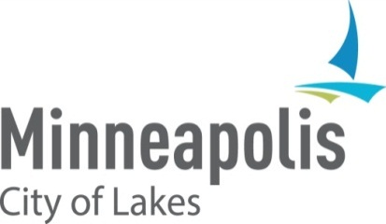

2025 HUD Consolidated Annual Performance and Evaluation Report (CAPER) NOTICE OF PUBLIC HEARING

When: Tuesday, August 18, 2026, at 1:30 p.m. before the Business, Housing and Zoning (BHZ) Committee.

Purpose: To receive comment on the City’s Draft 2025 CAPER for CDBG, HOME, ESG, and HOPWA federal entitlement funding.

The City of Minneapolis invites you to review and comment on its draft FY 2025 Consolidated Annual Performance and Evaluation Report (CAPER).
This report explains how the City used federal funding during the 2025 program year for:
- Community Development Block Grant (CDBG)
- HOME Investment Partnerships Program (HOME)
- Emergency Solutions Grants (ESG)
- Housing Opportunities for Persons with AIDS (HOPWA)
You can read the draft report here: https://tinyurl.com/58va9jd8
You may send written comments to matthew.bower@minneapolismn.gov between August 11, 2026, and August 25, 2026. You can also share your comments during the public hearing.
The City plans to submit the final CAPER to the U.S. Department of Housing and Urban Development (HUD) on August 29, 2026.
To learn how to take part in the public hearing, visit: https://www.minneapolismn.gov/government/city-council/meetings/participate-in-a-meeting/ or call 311 or 612-673-3000.
If you need a reasonable accommodation or would like the report in another format, contact Finance and Property Services at 612-673-3000 or email finance@minneapolismn.gov. The City can provide CAPER materials in alternative formats. People who are deaf or hard of hearing can use a relay service to call 311 at 612-673-3000.

Para ayuda, llame al 311. Rau kev pab, hu 311. Hadii aad caawimaad u baahantahay, wac 311.

